Landlord testing:
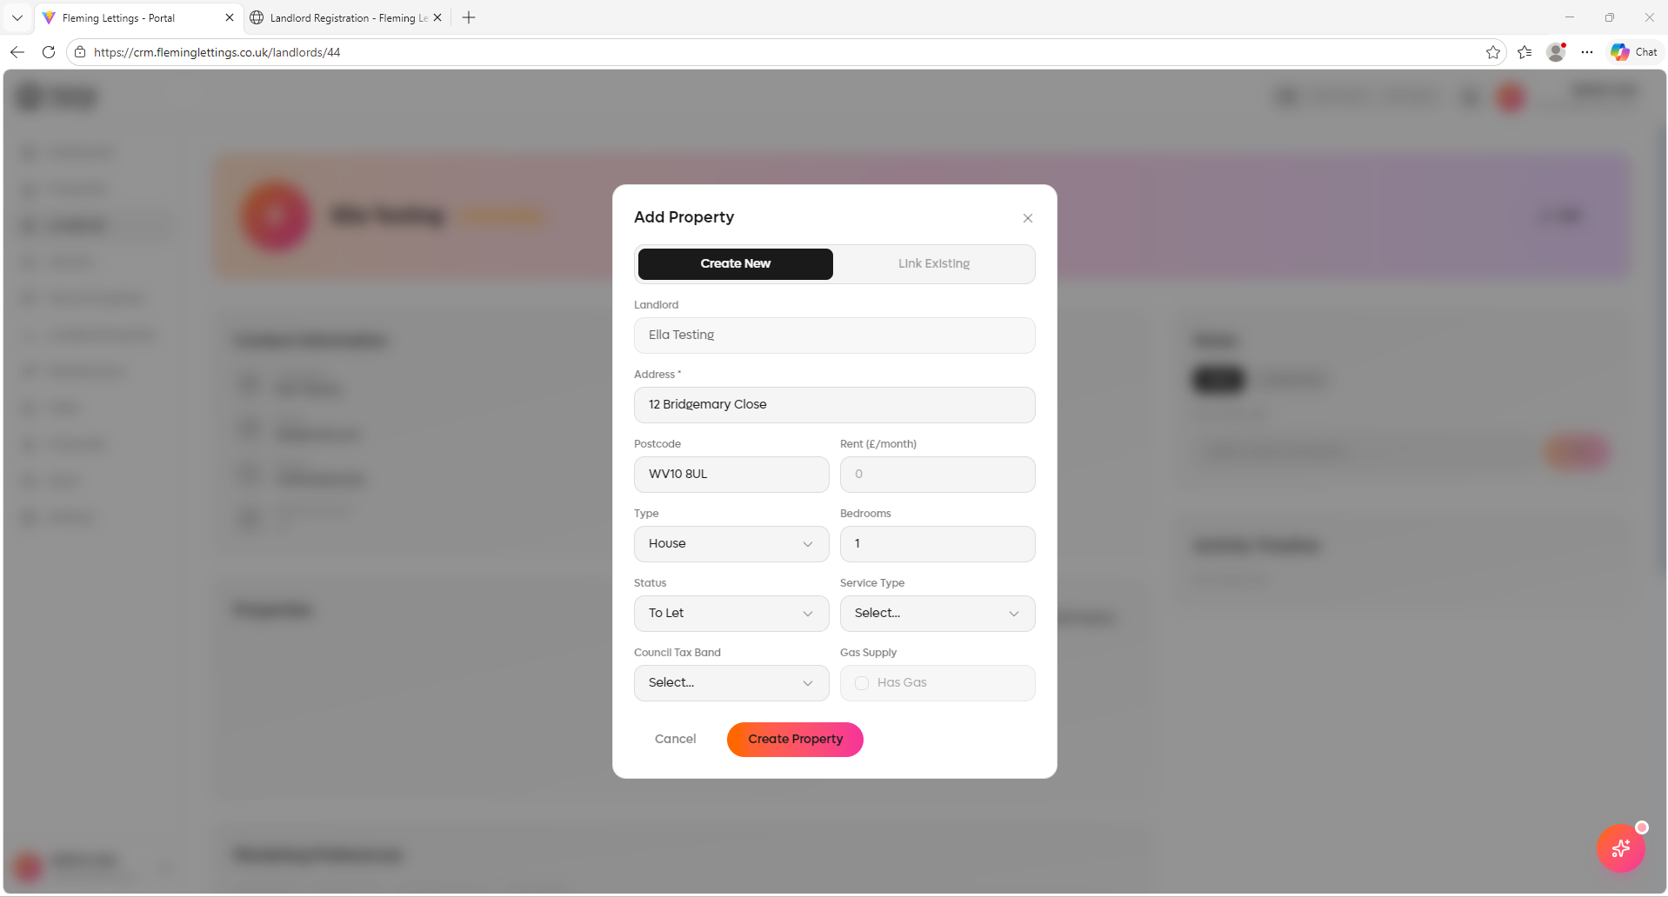
Address pre-population should work when adding a property under a landlord page. i.e. user types: 8 Bridg – and it should populate addresses for the user to select. It of course will need an option to ‘Manually Enter’ the address as an override.
Postcode needs to be mandatory.

Status options do not make logical sense. please remove this option. Council tax band and gas supply question should not be on this page as well. Please remove.

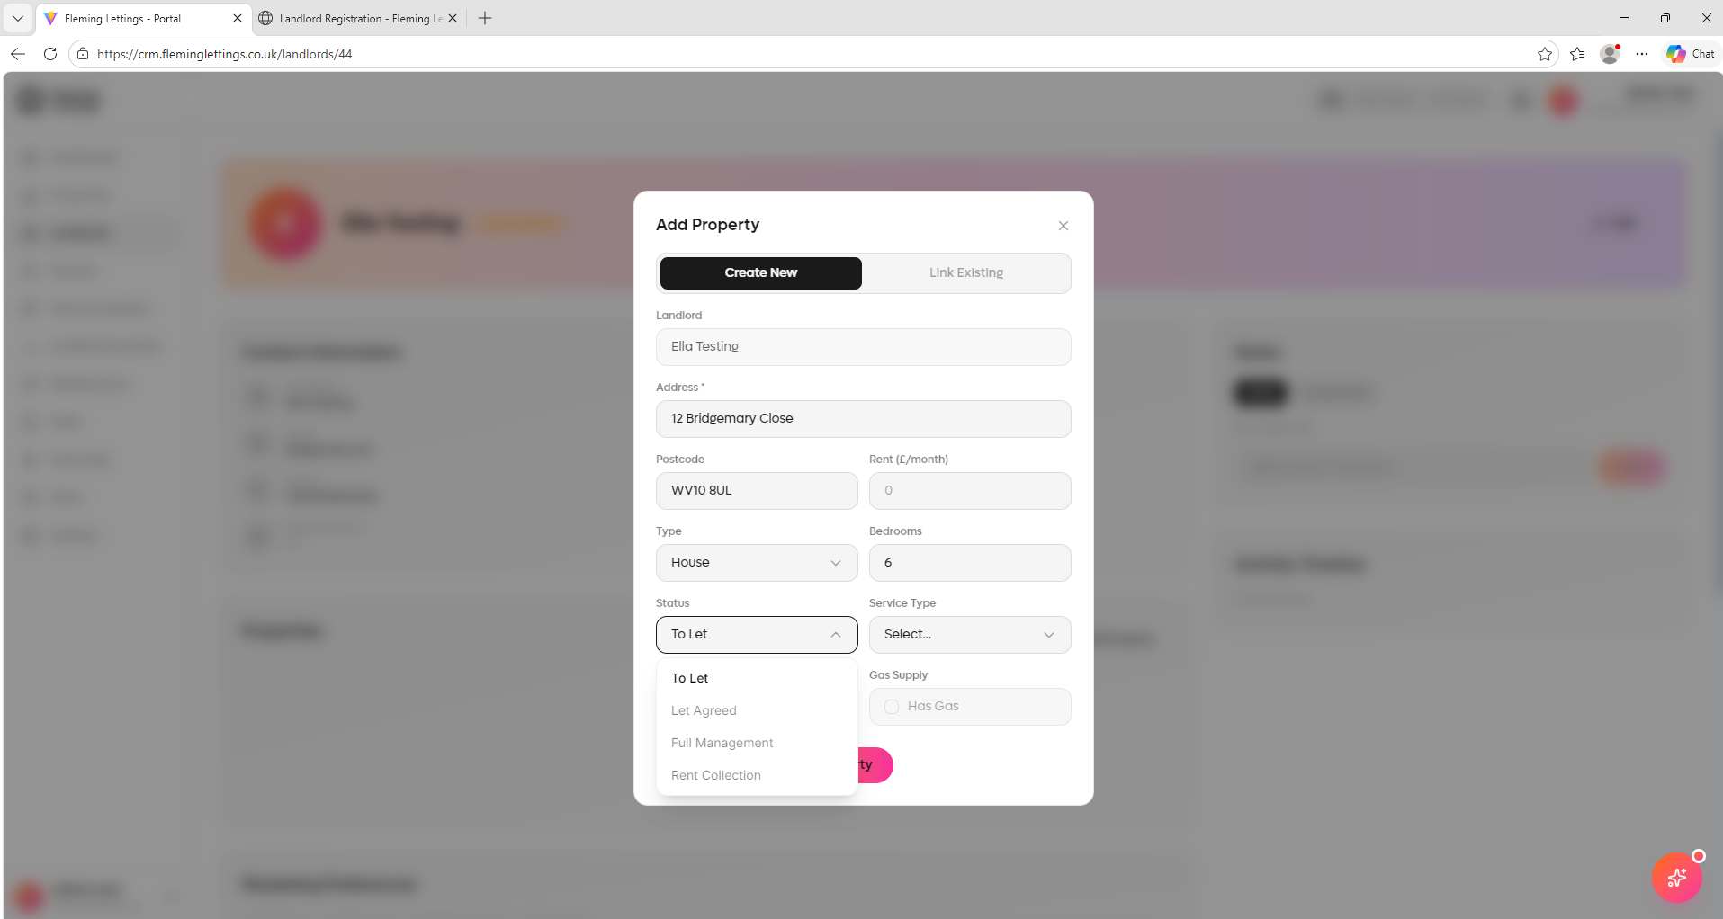

The form does not also work when you click ‘Create Property’
Please fix this. What should happen is that it created a property record, shown under ‘Properties’ page and lists this property under the landlord’s record. Again, activity notes should be left when the user creates this.
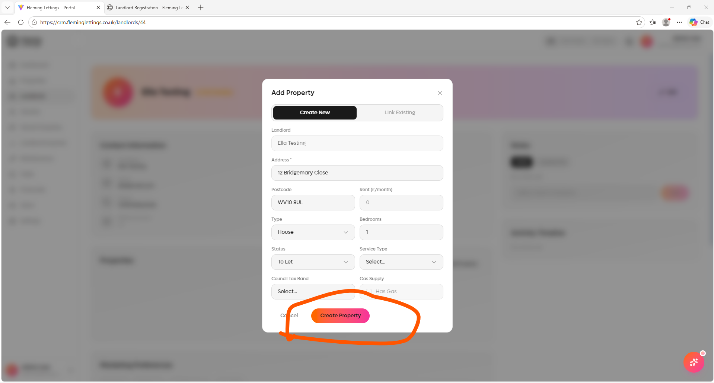

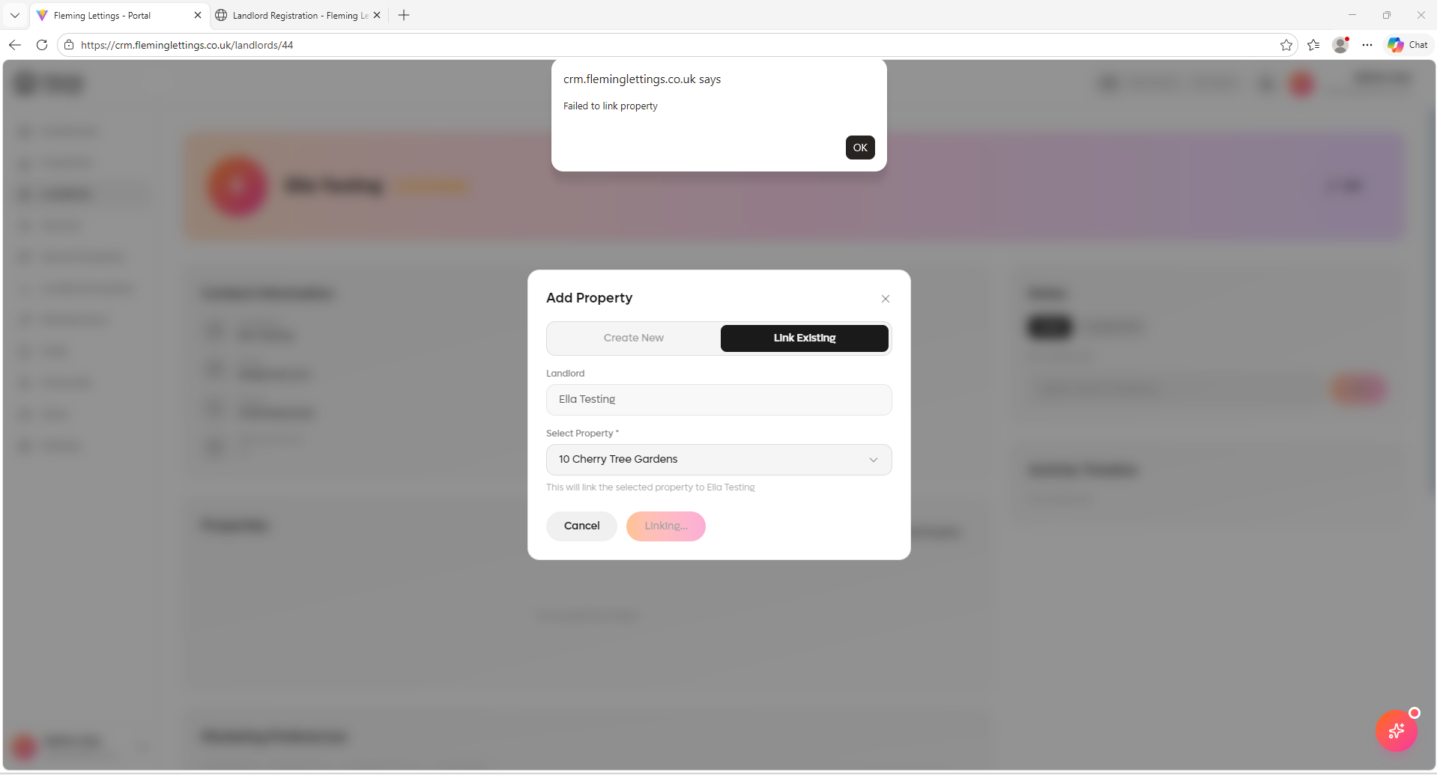
When trying to link an existing property is presents this error message. Please fix this.
Please note that it should be possible for multiple landlords to be linked to a single property. The reason for this is that the joint landlords might have separate or joint portfolios and share ownership within a single property. Also, any limited company records need to be linked to this as well where relevant.

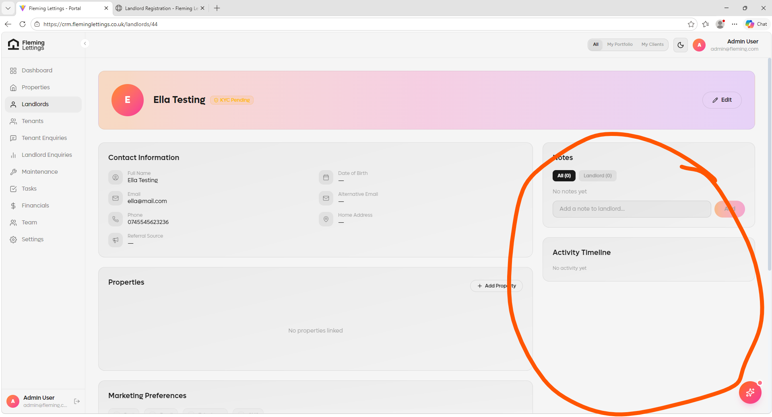
Activity tracking is again not working here. When a user views the record or creates it; it should leave a timestamp log under the activities record.

SMS and Emails functionality and tracking are missing as per the tenant enquiry record. Please ensure that these are showing and working on the landlords pages.

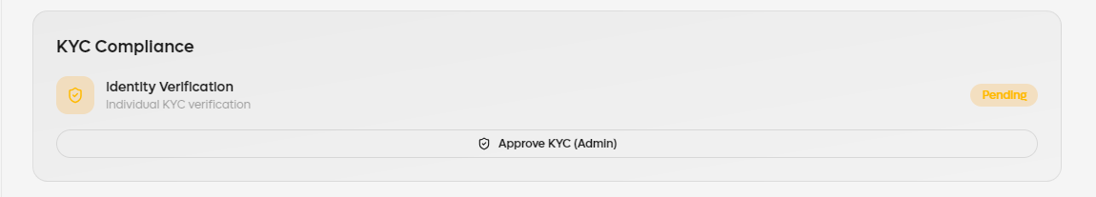
KYC Compliance needs to show like it does on tenant enquiry record in the same format within the ‘Personal Information’ section.
